# Unity Beginner Tutorials

## Lec 12 – How to BUILD / EXPORT your Game in Unity

Watch video

## Lec 13 – Top 10 Unity Tips

* Debug mode: Set inspector to Debug mode to show even private variables
* Find a good view in scene mode -> select the camera -> press ctrl+shift+f => Aligns with view (or select from GameObject menu bar)
* Variable attributes:
  + [Range(.1f, 2f)]
  + [Header(“Transform”)]
  + [Space]
  + [HideInInspector] : variable will hide in inspector if public
  + [SerializedField] : variable will show in inspector if private

## Lec 14 – How to make a High Score

PlayerPrefs -> Object serialization and deserialization tool

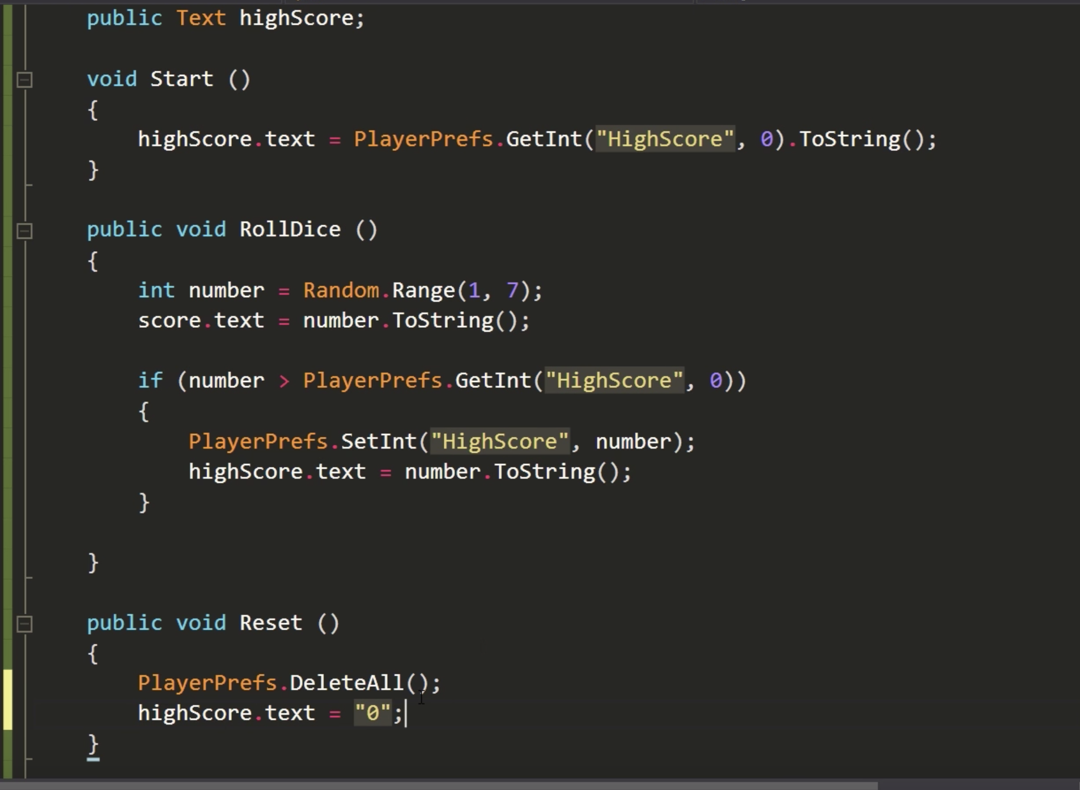

## Lec 15 – Top 10 Unity Tips #2

* Double tap ‘F’ to lock on an object in scene view even while playing
* [Tooltip(“some tip that will display on hover over the variable”)]
* Type for and double tap ‘Tab’ to generate basic for loop. Also works with other statements like if, while, foreach, switch etc.
* #region <Description>, #endregion
* Documentation – Book icon on top right in inspect view
* Alt + expand an object in hierarchy: expands all sub objects  
  similarly while contracting press Alt

## Lec 16 – Smooth Camera Flow in Unity

using UnityEngine;

public class CameraFollow : MonoBehaviour {

public Transform target;

public float smoothSpeed = 0.125f;

public Vector3 offset;

void FixedUpdate ()

{

Vector3 desiredPosition = target.position + offset;

Vector3 smoothedPosition = Vector3.Lerp(transform.position, desiredPosition, smoothSpeed);

transform.position = smoothedPosition;

transform.LookAt(target);

}

}

^^ Don’t use this, use: Vector3.SmoothDamp

Lerp() is NEVER good for moving targets

## Lec 17 – How to get good graphics in Unity

Watch the video

## Lec 18 – Introduction to audio in Unity

Create new Object (also prefab if required)-> AudioManager

AudioManager.cs:

using UnityEngine.Audio;

using System;

using UnityEngine;

public class AudioManager : MonoBehaviour

{

public static AudioManager instance;

public AudioMixerGroup mixerGroup;

public Sound[] sounds;

void Awake()

{

if (instance != null)

{

Destroy(gameObject);

}

else

{

instance = this;

DontDestroyOnLoad(gameObject);

}

foreach (Sound s in sounds)

{

s.source = gameObject.AddComponent<AudioSource>();

s.source.clip = s.clip;

s.source.loop = s.loop;

s.source.outputAudioMixerGroup = mixerGroup;

}

}

public void Play(string sound)

{

Sound s = Array.Find(sounds, item => item.name == sound);

if (s == null)

{

Debug.LogWarning("Sound: " + name + " not found!");

return;

}

s.source.volume = s.volume * (1f + UnityEngine.Random.Range(-s.volumeVariance / 2f, s.volumeVariance / 2f));

s.source.pitch = s.pitch * (1f + UnityEngine.Random.Range(-s.pitchVariance / 2f, s.pitchVariance / 2f));

s.source.Play();

}

}

Create Sound.cs script which don’t need to exist in any Object

using UnityEngine.Audio;

using UnityEngine;

[System.Serializable]

public class Sound {

public string name;

public AudioClip clip;

[Range(0f, 1f)]

public float volume = .75f;

[Range(0f, 1f)]

public float volumeVariance = .1f;

[Range(.1f, 3f)]

public float pitch = 1f;

[Range(0f, 1f)]

public float pitchVariance = .1f;

public bool loop = false;

public AudioMixerGroup mixerGroup;

[HideInInspector]

public AudioSource source;

}

To use:

FindObjectOfType<AudioManager>().Play(“PlayerDeath”);

## Lec 19 – Powerups in Unity

Download the unity particle pack <https://assetstore.unity.com/packages/essentials/asset-packs/unity-particle-pack-5-x-73777?aid=1101lPGj&utm_source=aff>

Make custom particle which gets destroyed: using Destroy (gameObject, 2f) in its script OR setting the Pickup/Powerup object as its parent.

New PowerUp object

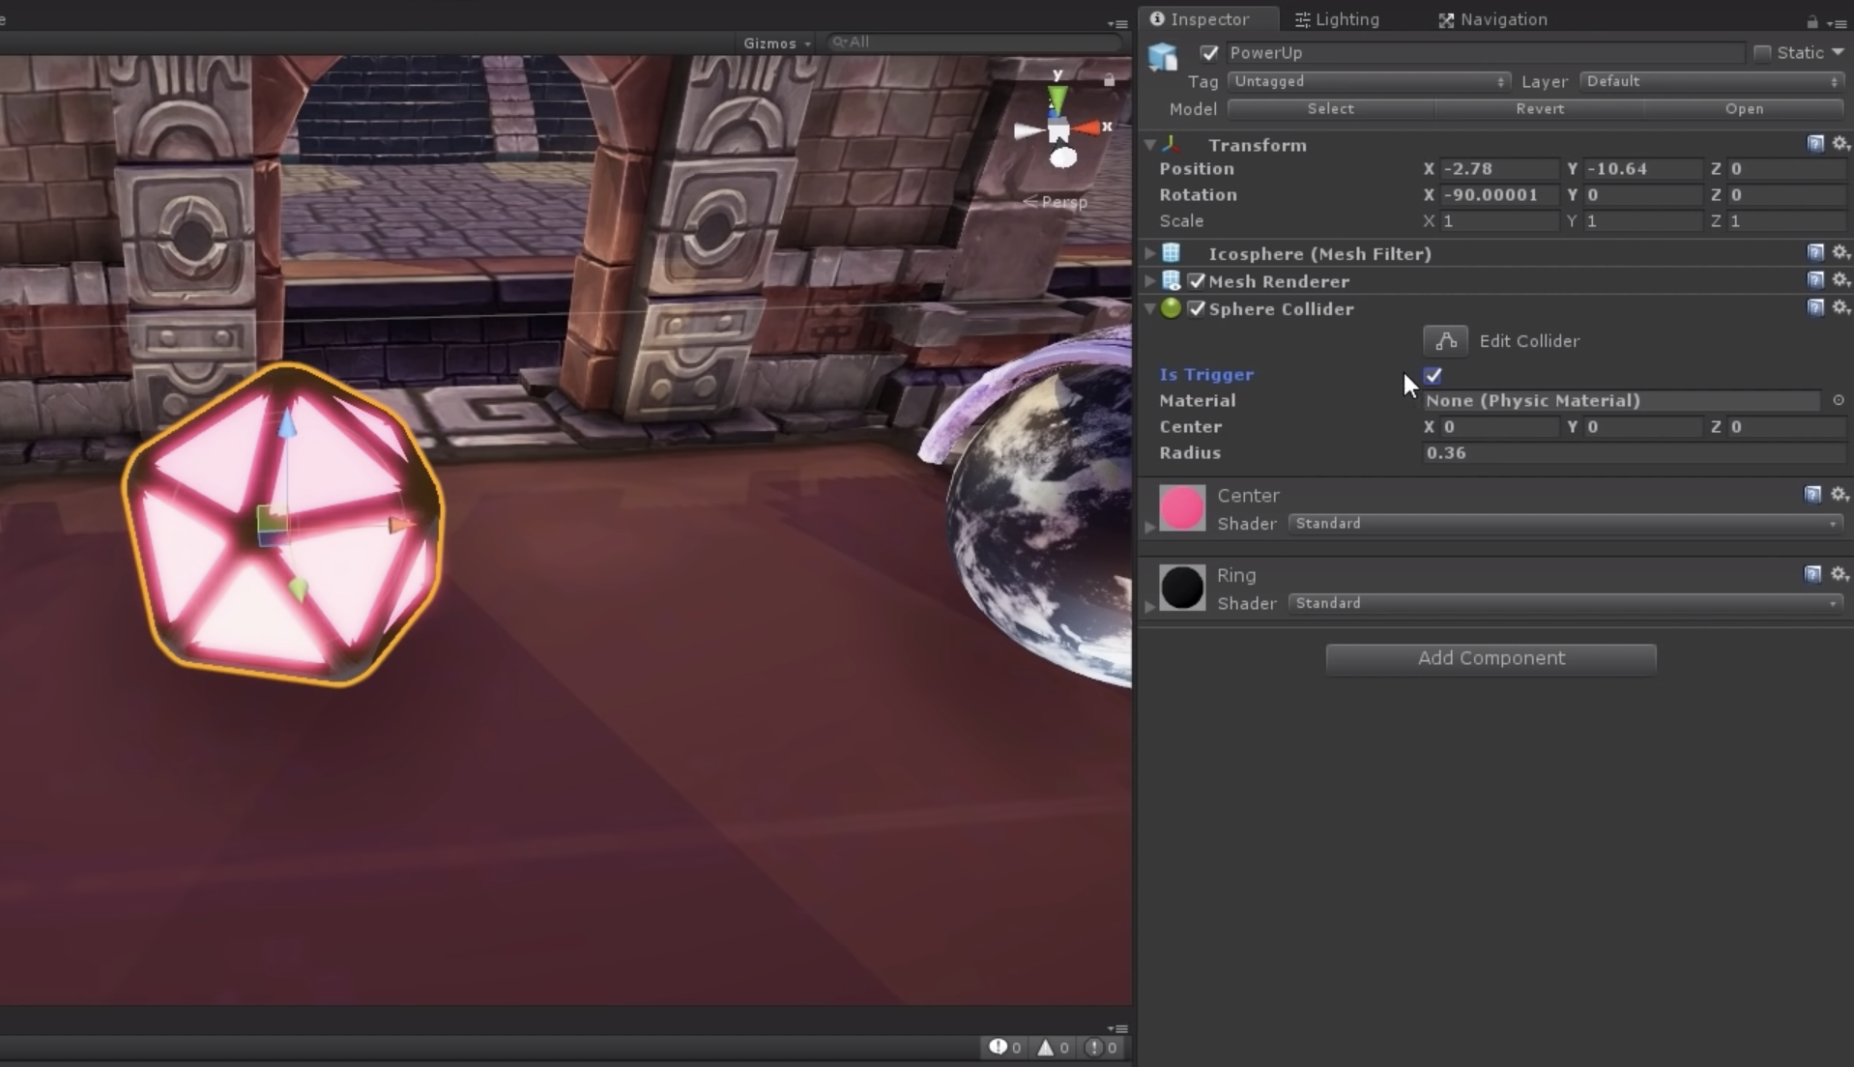

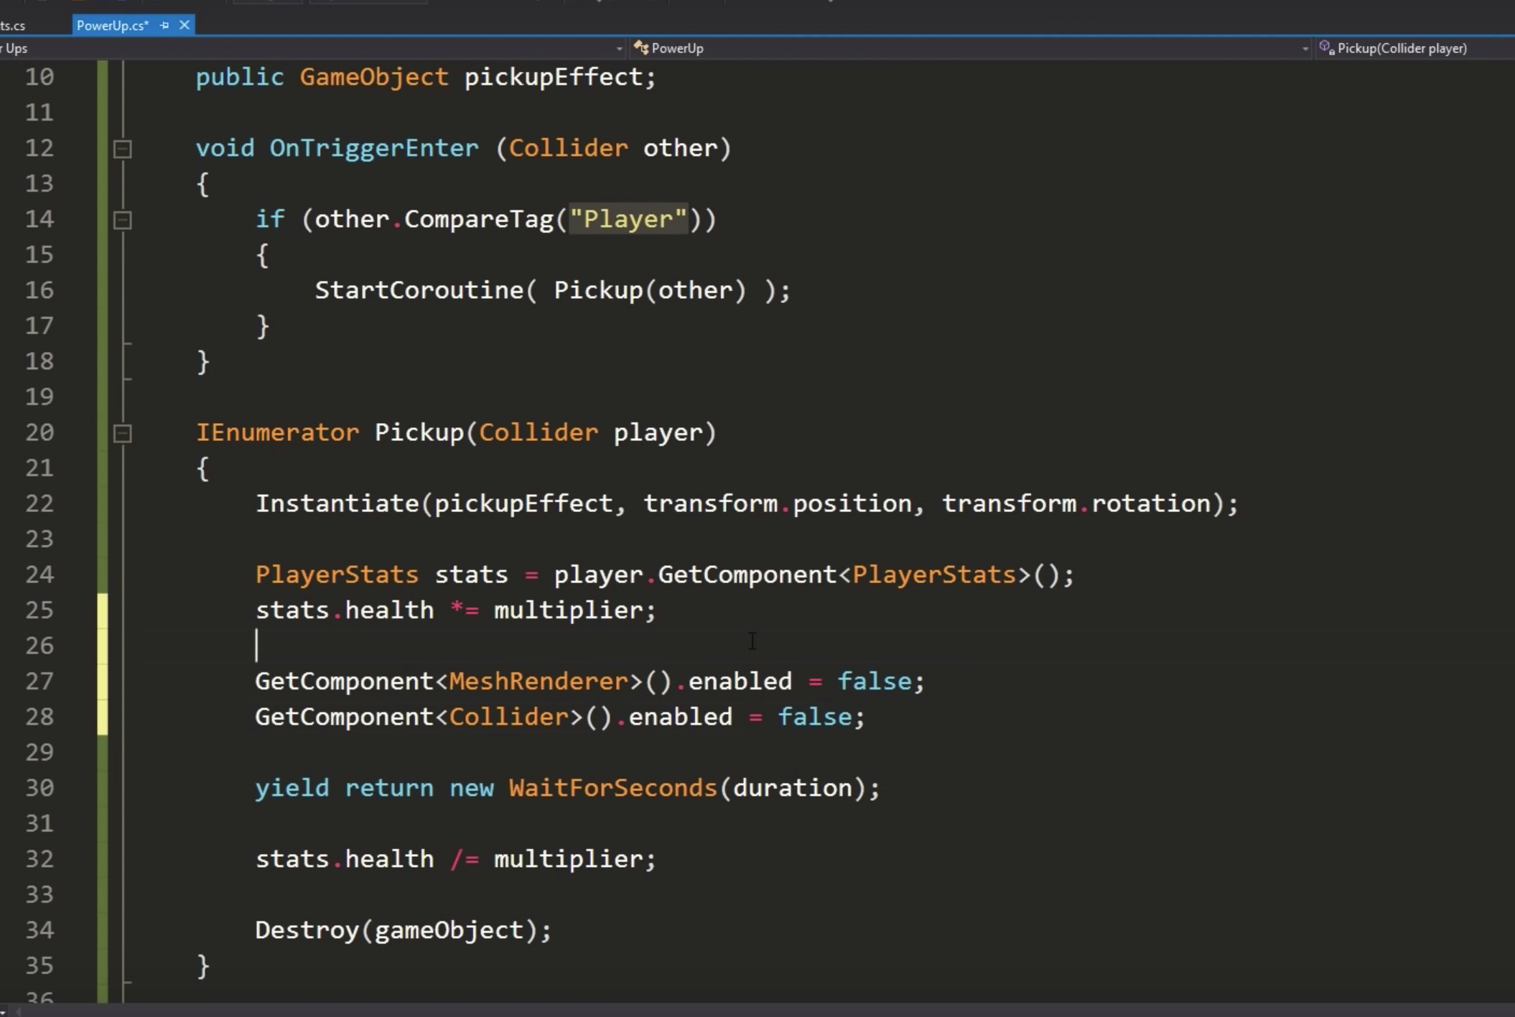

Different powerups example:

PowerUpsAvailable.cs

public enum PowerUpsAvailable

{

Grow,

HealthBoost

}

Then we can add an object in the PowerUp class.

public PowerUpsAvailable powerUpType; // It’s option will be shown in the inspector

….

switch (powerUpType)

{

case PowerUpsAvailable.Grow:

//Do something

break; //We don't want errors!

case PowerUpsAvailable.HealthBoost:

//Do something else

break;

default:

Debug.Log("The type is invalid");

break;

}

## Lec 20 – Baked Lightning in Unity – Using Progressive Lightmapper

Watch the video

## Lec 21 – Tilemaps in Unity

Import [Tiles](https://www.youtube.com/redirect?q=http%3A%2F%2Fdownloads.brackeys.com%2Ftutorials%2FTilesetExample.psd&redir_token=2My6VqptBLodnU1gpw0elWaeoNZ8MTU2MzY0Njc2MUAxNTYzNTYwMzYx&event=video_description&v=ryISV_nH8qw) images in project resources

Change its setting to following:

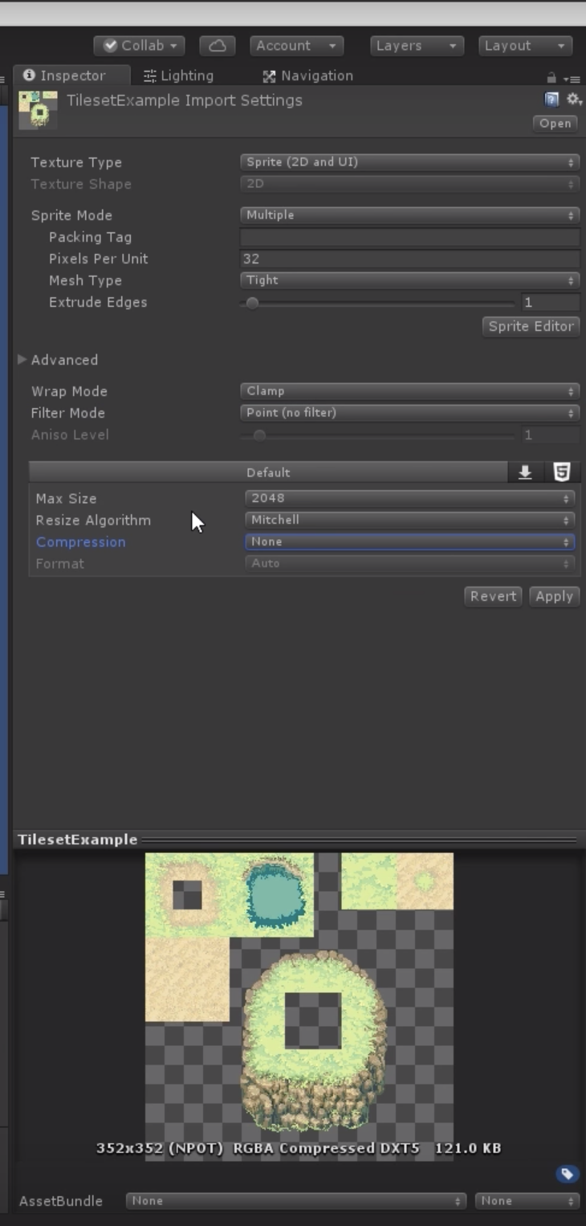

In Sprite Editor Slice Grid by cell size (32x32 in this case)

Create new Tilemap Game object. A single tilemap in the grid object is a layer.

Window -> Tilepalette -> Create a new palette

Drag the parent of Tiles images in the palette

Paint!

Edit -> Project Settings -> Quality -> Antialiasing -> Disabled => removes the boundaries faced in the scene

Tilmap extra features: <https://github.com/Unity-Technologies/2d-extras>

Examples: <https://github.com/Unity-Technologies/2d-techdemos>

Project resource -> right click -> Create -> Animated tile

Number of animated sprites -> 5

Grid -> Tilemap -> Animation frame rate -> 15

Rule based tile: Tile Palette -> Terrain Tiles

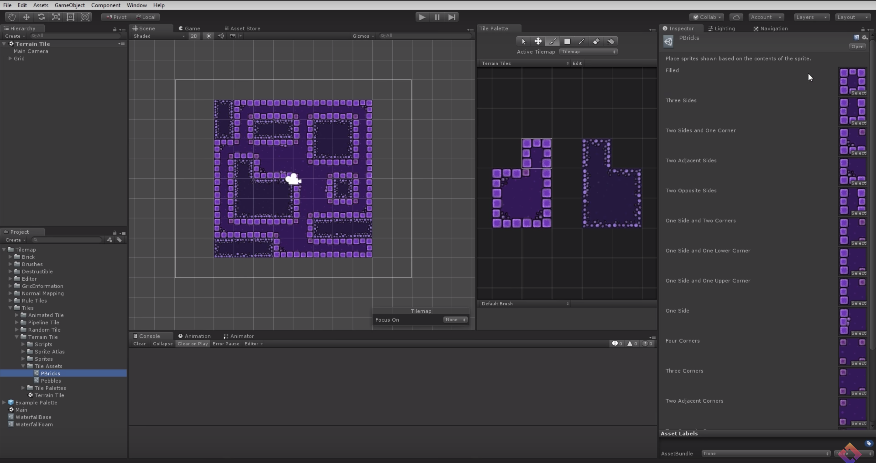

## Tileset in Photoshop

Watch video <https://www.youtube.com/watch?v=aaEEujLtsr8>

## Pixel Art in Photoshop

Watch video <https://www.youtube.com/watch?v=rLdA4Amea7Y>

## Lec 22 – Everything to know about Particle System

Watch video/Read documentation

## Lec 23 – Realtime Lighting in Unity

Watch video

## Lec 24 – Camera Shake in Unity

CameraShake.cs:

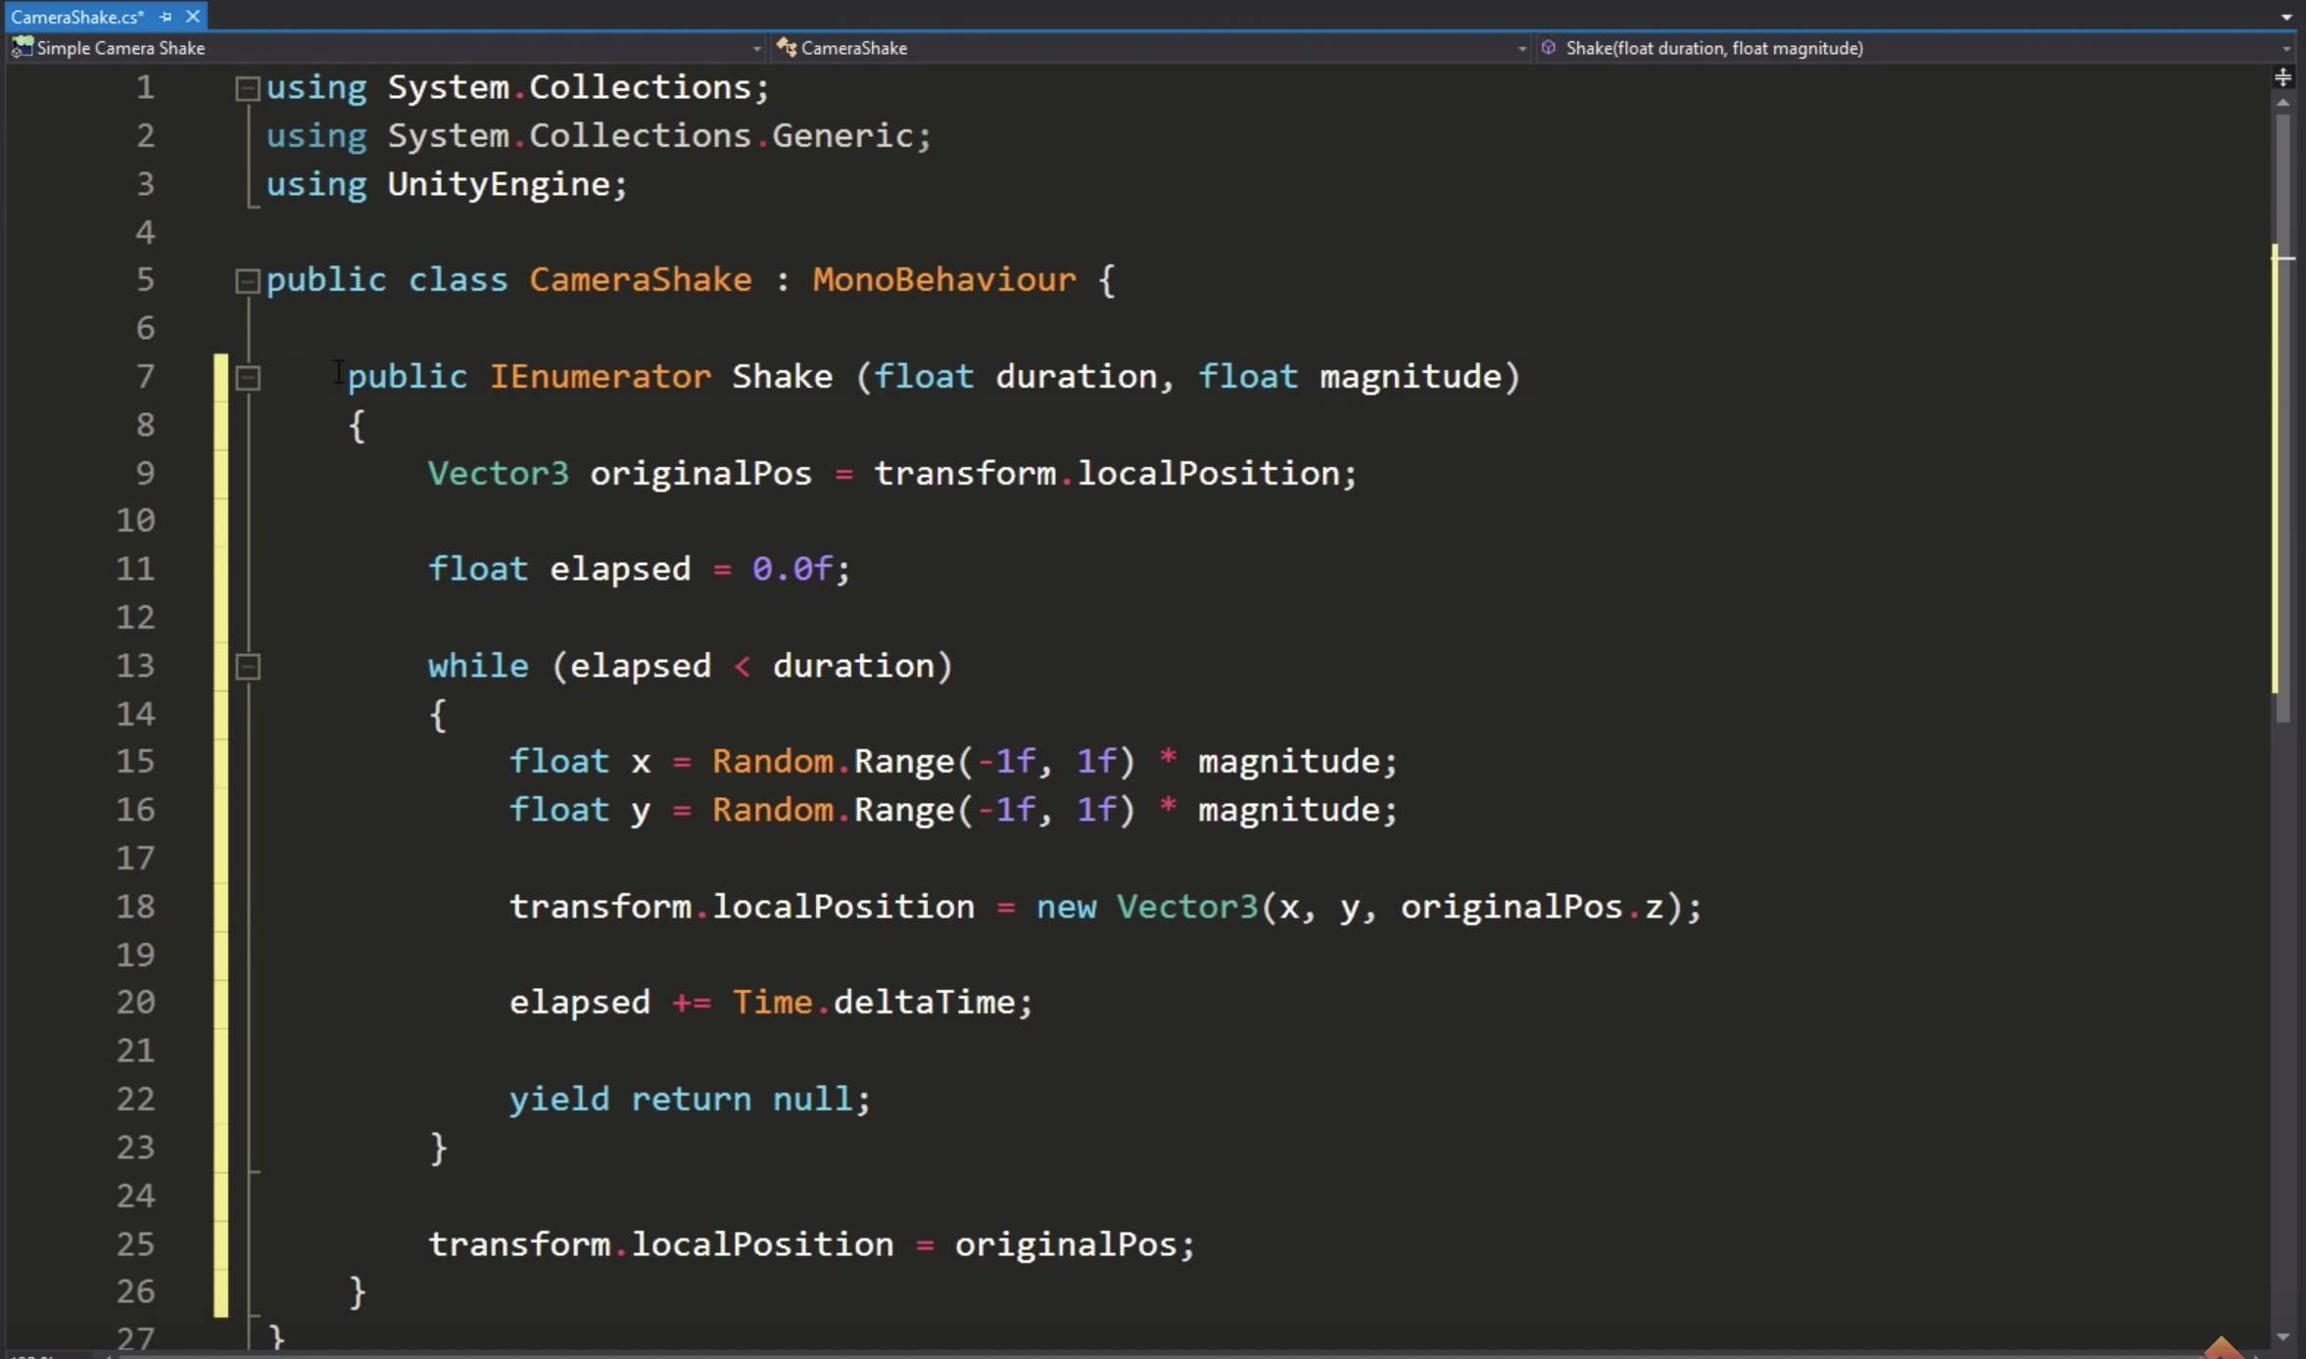

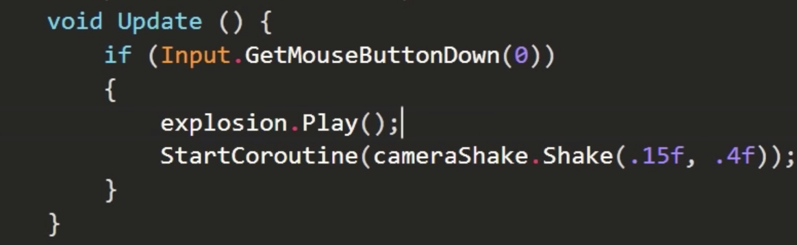

Create a new CameraHolder object -> set its position to MainCamera position (trick to do this: create the Cameraholder object as a child of MainCamera, then move it outside the hierarchy, them move MainCamera inside the CameraHolder)

Move MainCamera inside the CameraHolder, make sure MainCamera position is 0,0,0 (reseted)

OR

Asset store -> EZ Camera Shake

MainCamera -> add CameraShaker

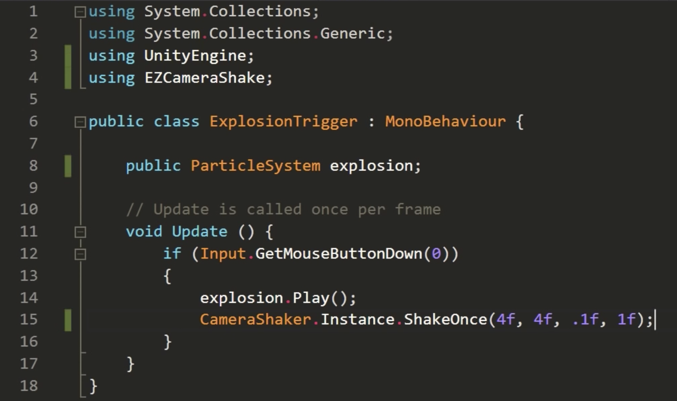

## Lec 25 –Unity Level of Detail (LOD) tutorial

In your .fbx file of Blender asset, add multiple models in different layers with names like

Monkey_LOD0 (highest detail)

Monkey_LOD1

Monkey_LOD2 (lowest detail)

Import the object in your game and unity will automatically switch to different details depending on the distance of the camera from the object.

## Lec 26 – Unity NavMesh tutorial

Create new gameobject -> Navmesh -> Add Nav Mesh Surface Script

Player object -> Create new layer -> add player to that layer => Ignore that layer in Navmesh object script

Walls object -> Add Nav Mesh modifier script -> Override Area -> Area Type = Not walkable

Affected agents in the Nav Mesh modifier script can be really useful

Player object -> Add Navmesh agent

Add PlayerController.cs:

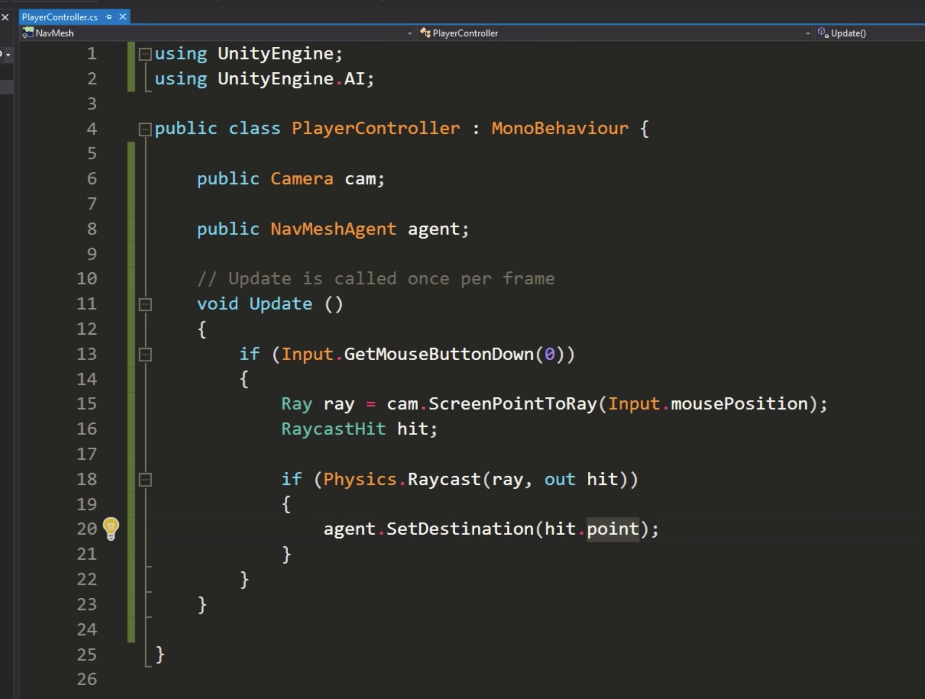

## Lec 27 – Scult, Paint & Texture in Unity

<https://assetstore.unity.com/packages/tools/modeling/polybrush-beta-111427?aid=1101lPGj&utm_source=aff>

Watch the video

## Unity Navmesh tutorial – More stuffs

<https://www.youtube.com/watch?v=FkLJ45Pt-mY>

Nav Mesh Modifier Volume Script -> allows creating holes within Navmesh by adding it to child object of Navmesh object

Making mesh dynamic if having moving obstacles:

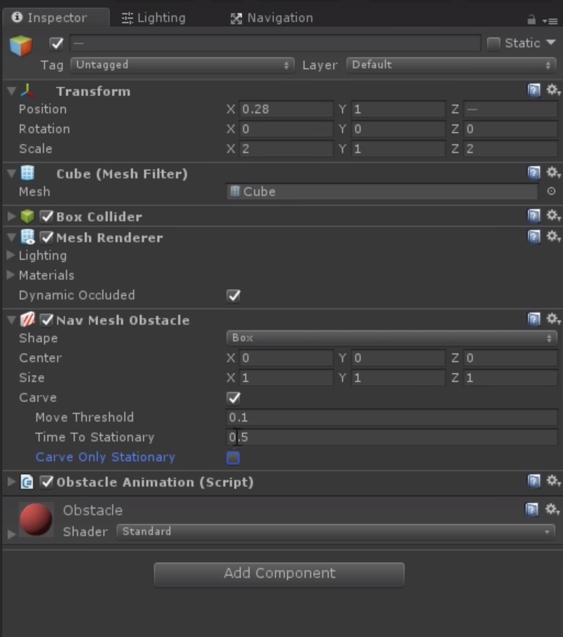

If carve is set to false then the player uses the ‘Obstacle Avoidance’ in its Navmesh agent script to avoid it.

Creating Navmesh when you generate random levels:

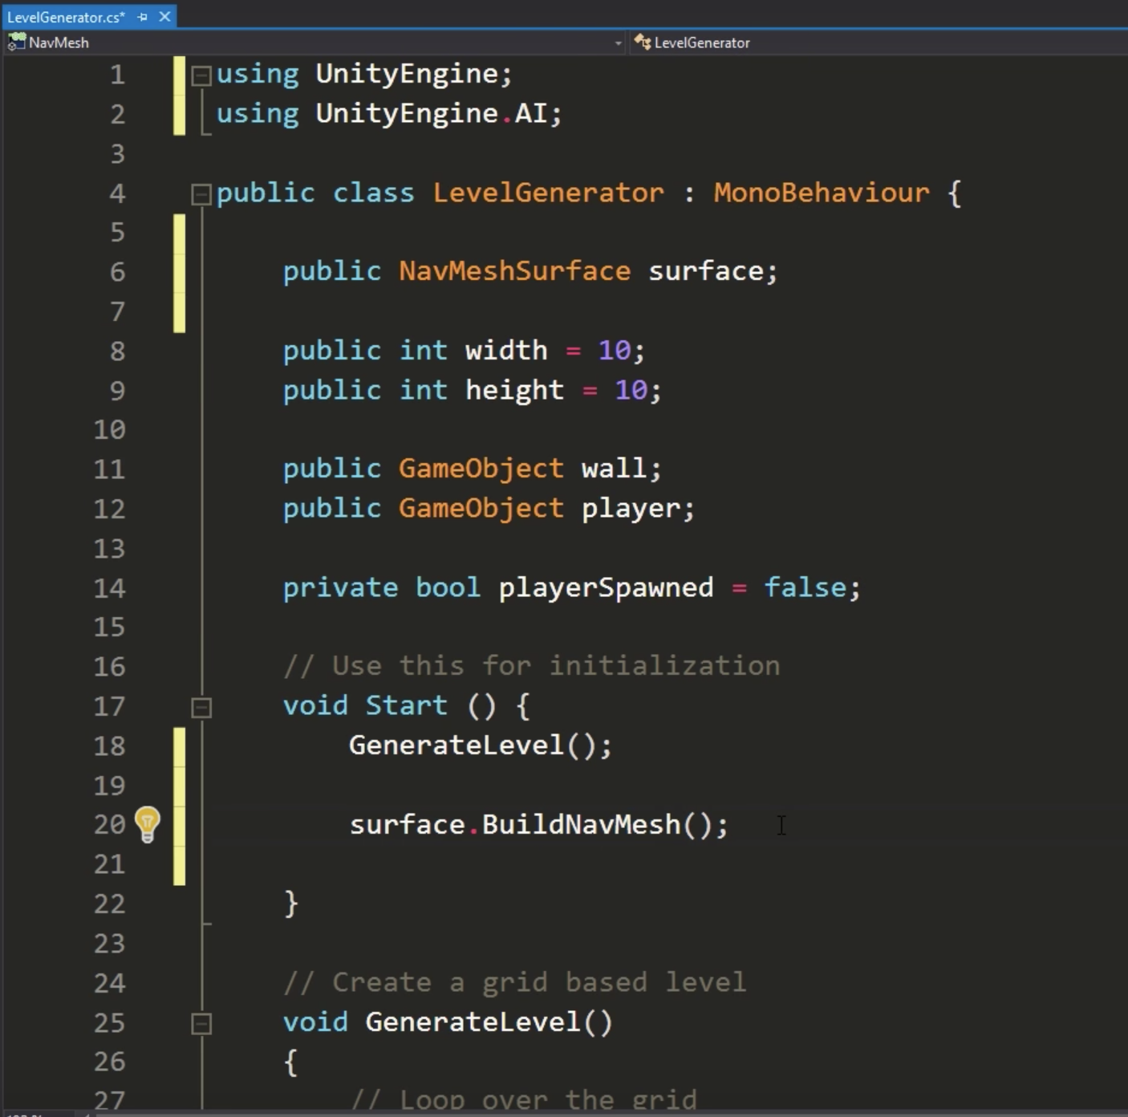

## Lec 28 – Unity NavMesh tutorial – Animated Character

<https://github.com/Brackeys/NavMesh-Tutorial>

Connecting two Navmesh:

Create new gameobject -> Add Nav Mesh Link Script => It executes a jump behavior

Animate player:

Player -> Remove Mesh Renderer, Capsule Collider & Mesh Filter

Add LowBody Model inside Player Heirarchy

Add LowBody Material to LowBody

Add Third Person Character Script to Player

Add Humanoid in Controller and LowBodyAvatar in Avator of Animator

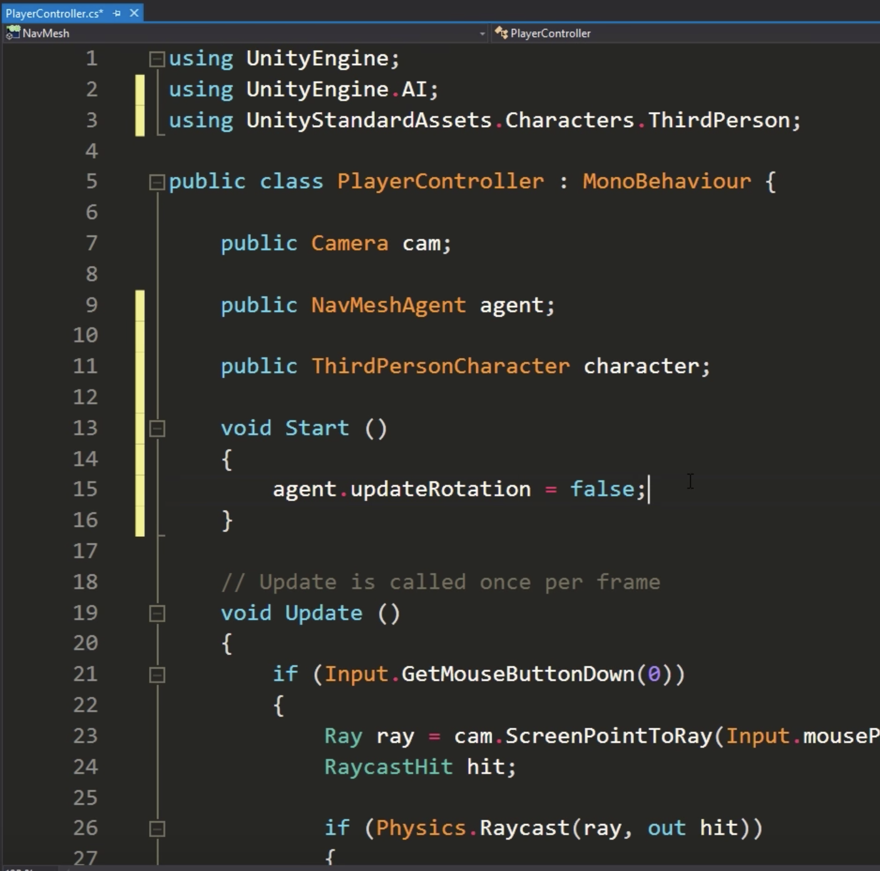

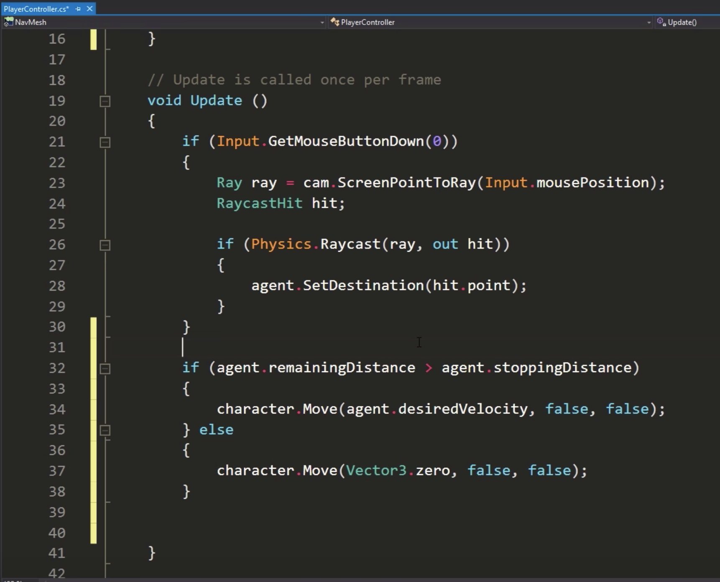

## Lec 29 – ProGrids tutorial

<https://assetstore.unity.com/packages/tools/modeling/progrids-2-x-111425?aid=1101lPGj&utm_source=aff>

Watch the video

## Lec 30 – Modeling in Unity: ProBuilder tutorial

<https://assetstore.unity.com/packages/tools/modeling/probuilder-2-x-111418?aid=1101lPGj&utm_source=aff>

Watch the video

## Lec 31 – Basics of Shader Graph

Create new shader graph asset -> apply it to a material which is applied to a Mesh object

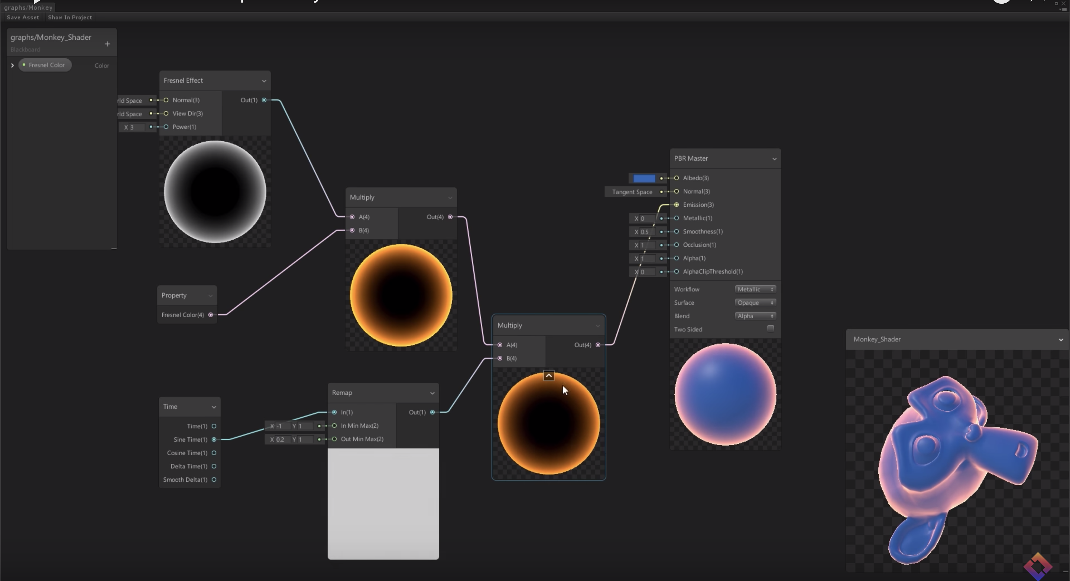

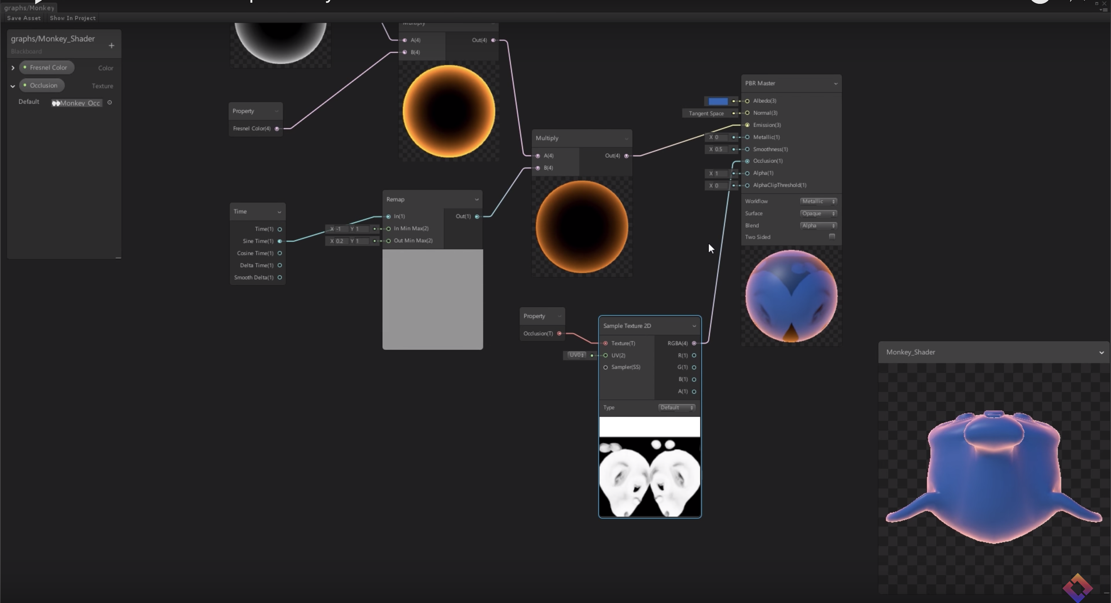

## Lec 32 – Hologram using Shader Graph

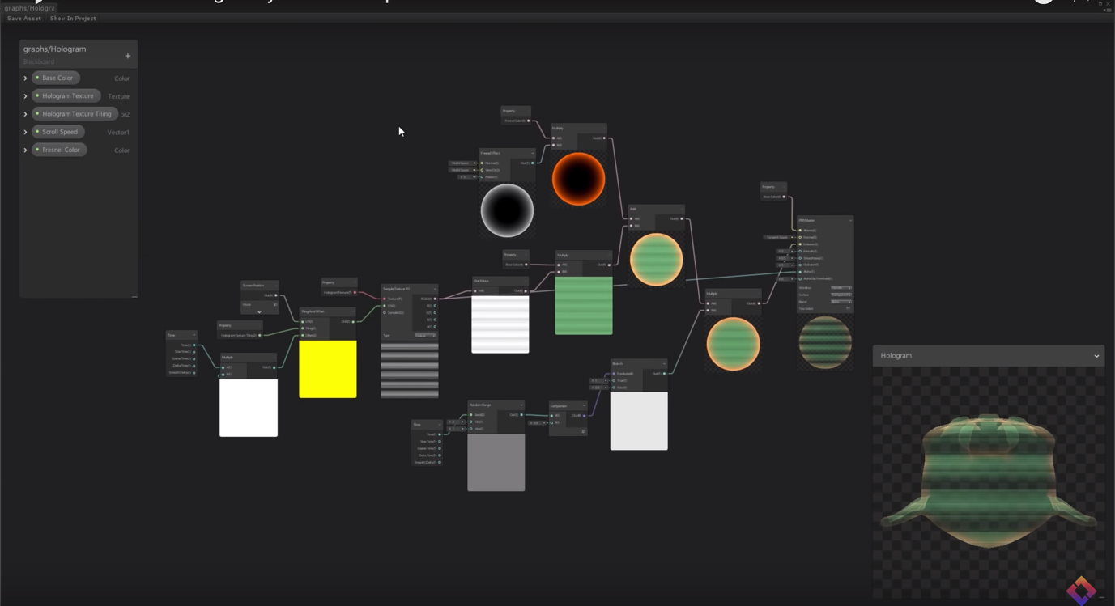

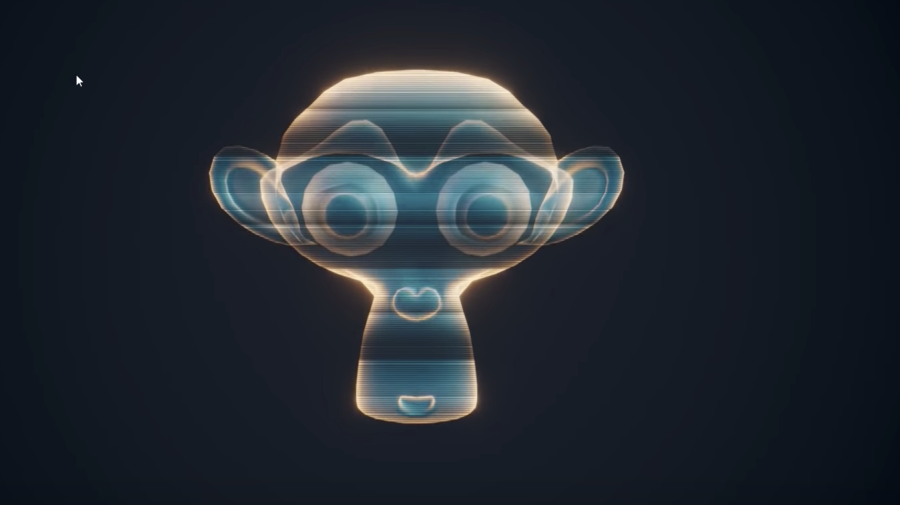

## Lec 33- Making Games without Code – Unity 3D game kit

<https://learn.unity.com/project/3d-game-kit>

<https://learn.unity.com/project/2d-game-kit>

## Lec 34- How to make a 2D game in Unity

Similar video like TileMap one

## Lec 35 – 2D Movement in Unity

2D Character controller script: <https://github.com/Brackeys/2D-Character-Controller>

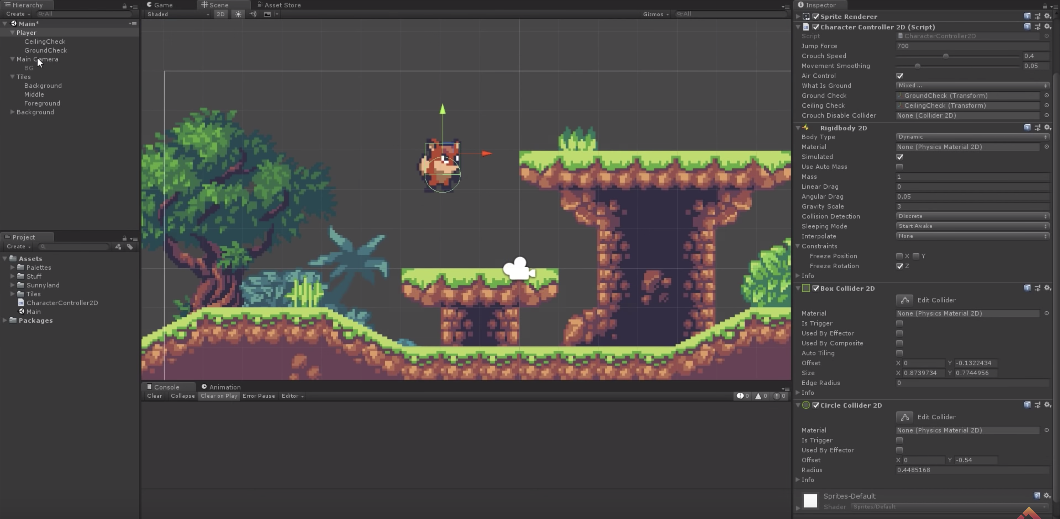

Player -> Character Controller 2D -> Crouch Disable collider -> Drag Box Collider 2D => Disables it while crouching

RigidBody -> Collision detection -> Continuous

Create new material -> Slippery -> Apply to Box collider & Circle collider material of player to avoid it getting stick on obstacles while jumping/falling

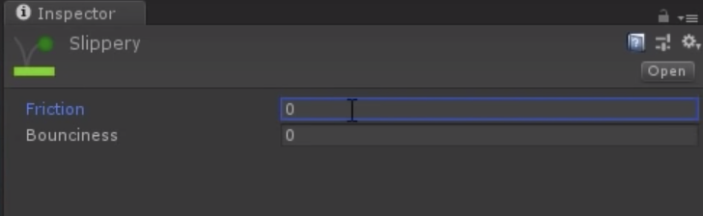

PlayerMovement.cs:

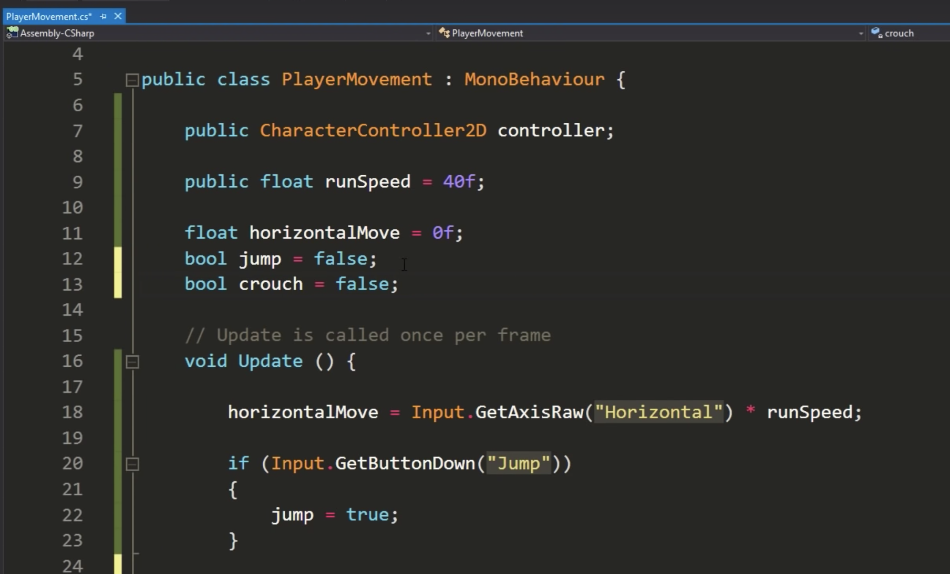

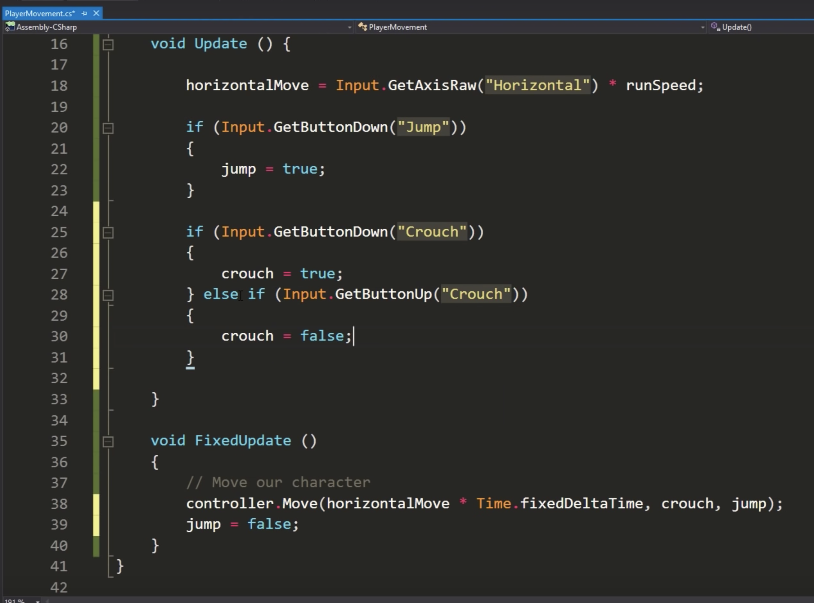

Edit -> Project settings -> Input => Configure buttons for input

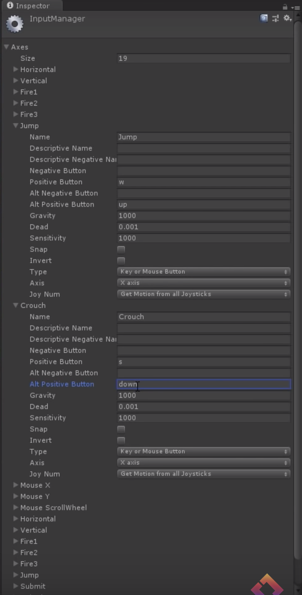

## Lec 36 – New Prefab Workflows

Prefab Mode -> Just like git modify and change properties overridden on a prefab by the game object.

Nested Prefab -> Can insert prefabs inside a prefab

Prefab Variants -> Can create variants of a prefab which are like a ‘child class’ of the original prefab. The new prefab is the original prefab with some more nested child prefabs/properties.

## Lec 37 – 2D camera using Cinemachine

Window -> Package Manager -> All -> Cinemachine -> Install

Watch video: <https://www.youtube.com/watch?v=2jTY11Am0Ig&list=PLPV2KyIb3jR5QFsefuO2RlAgWEz6EvVi6&index=38&t=0s>

## Lec 38 – 2D Shooting in Unity

CharacterController2D.cs:

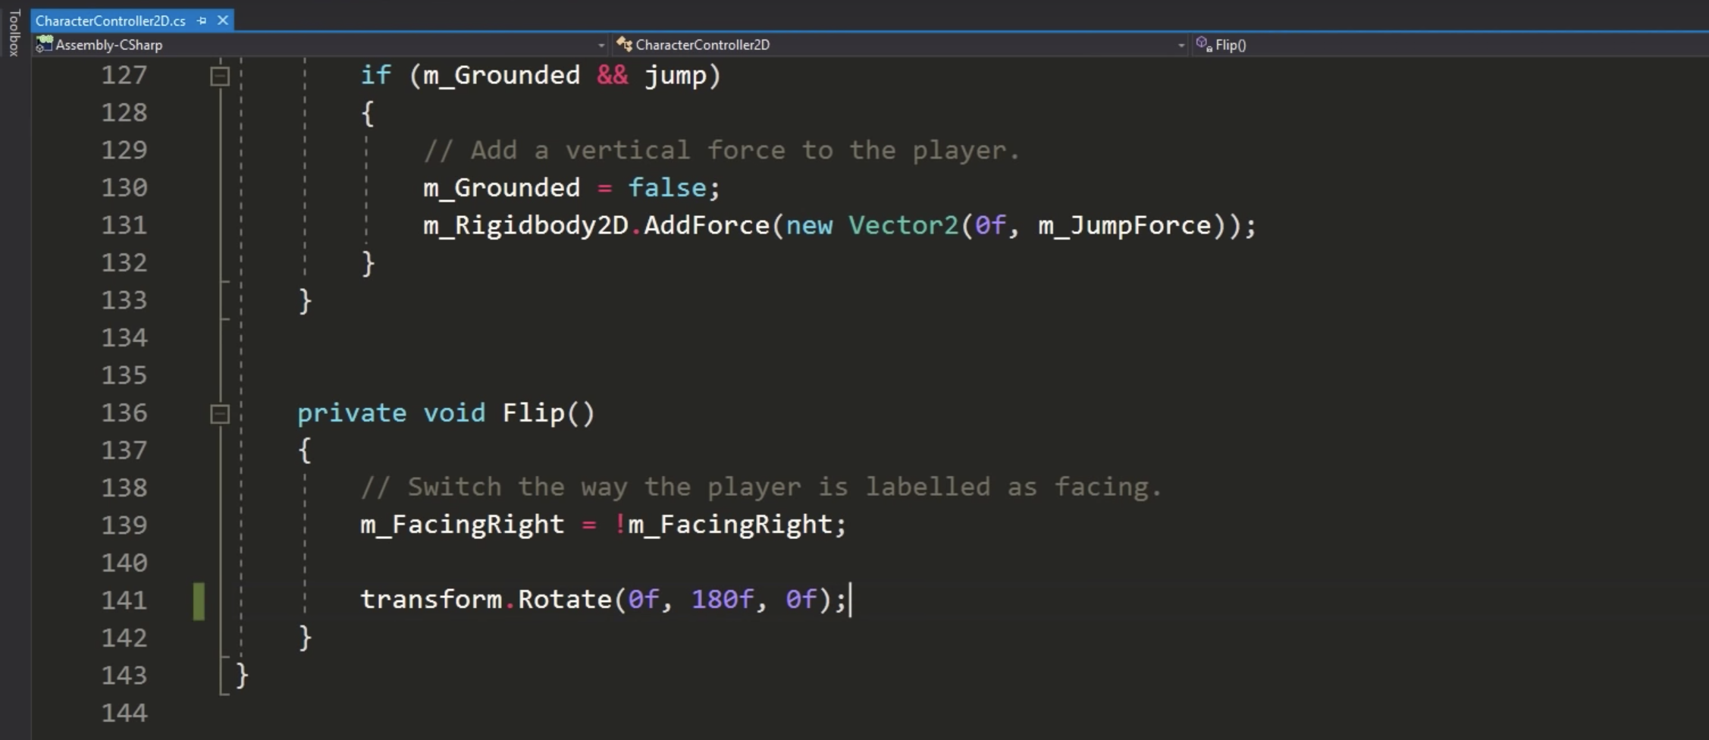

Add a firepoint GameObject in Player containing the starting position of fire

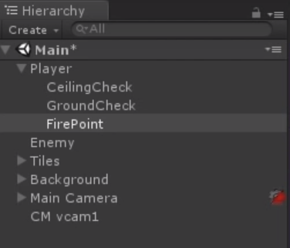

### **Using Prefabs**

Player -> Weapon.cs

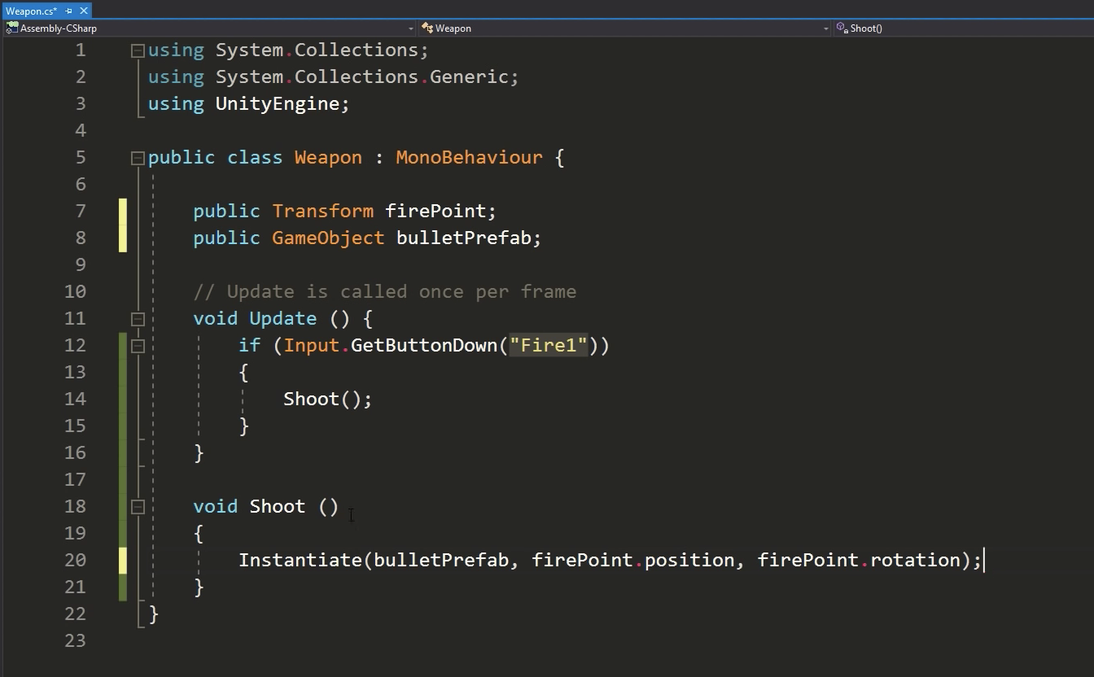

Create a bullet prefab:

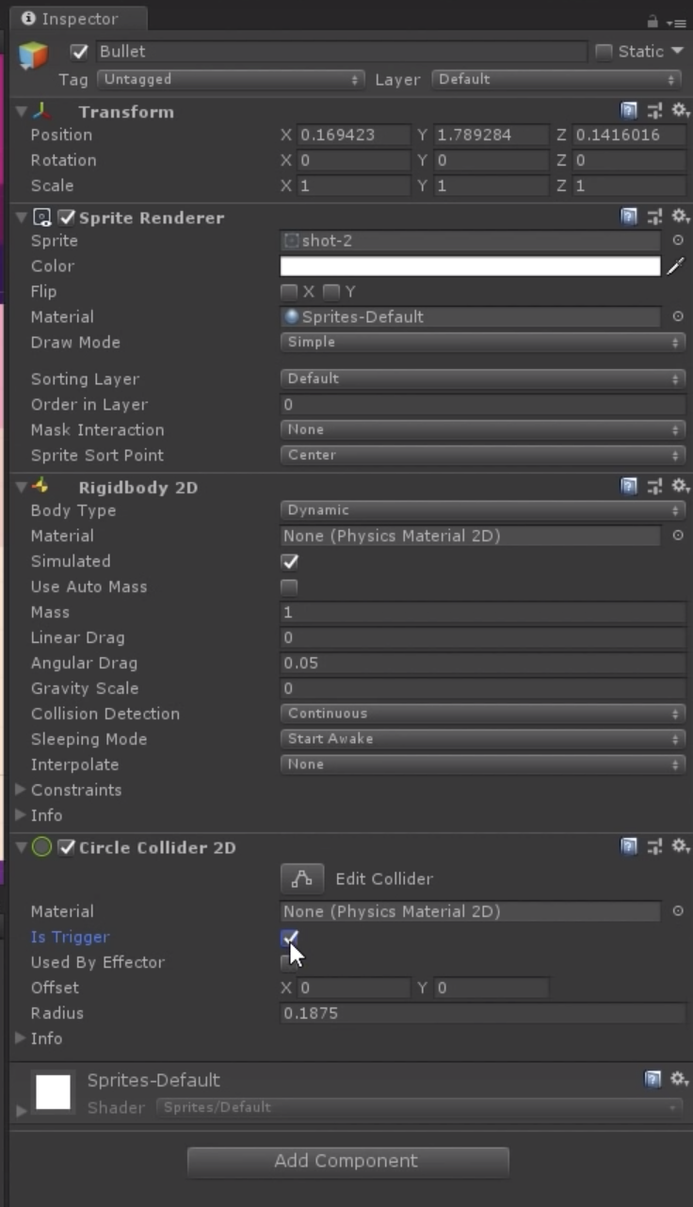

Bullet.cs:

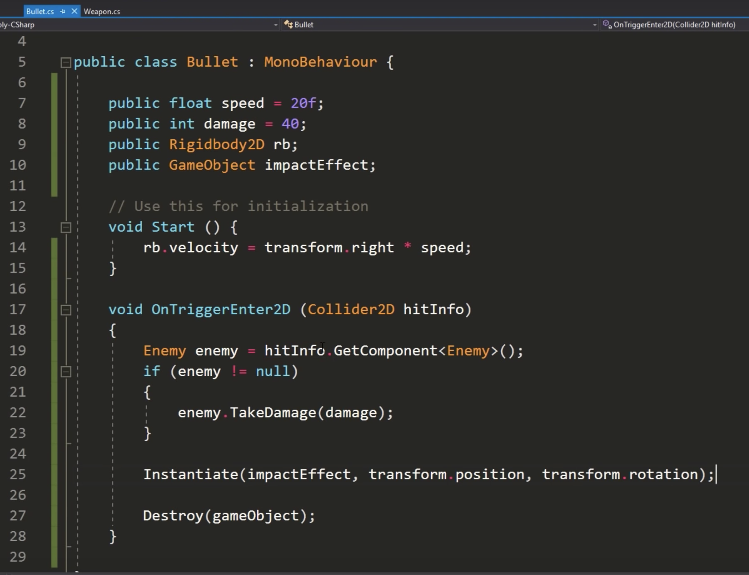

### **Using Ray Tracing**

Player -> Weapon.cs

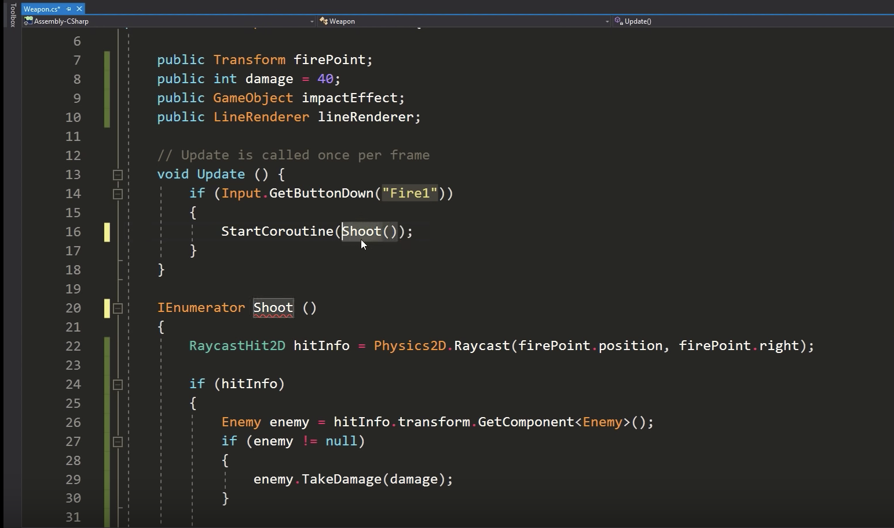

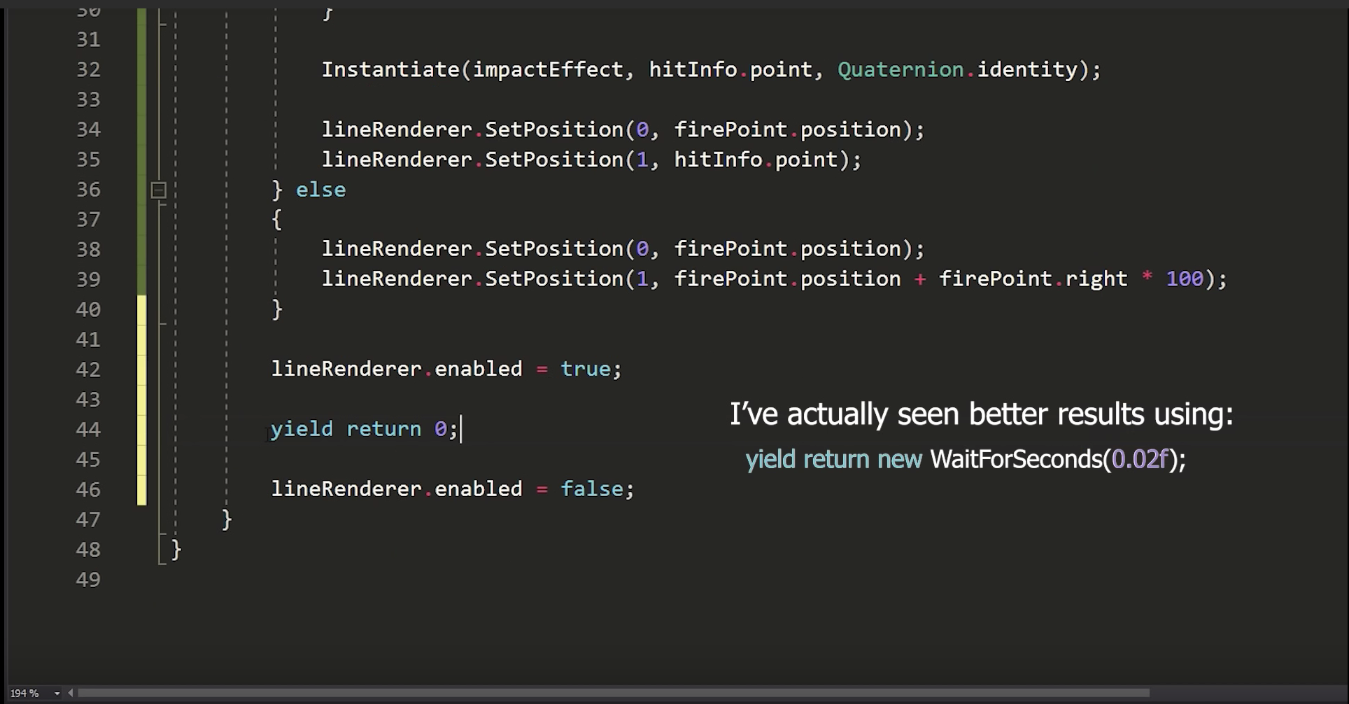

Right click hierarchy -> Effects -> Line => Make it a child of Player

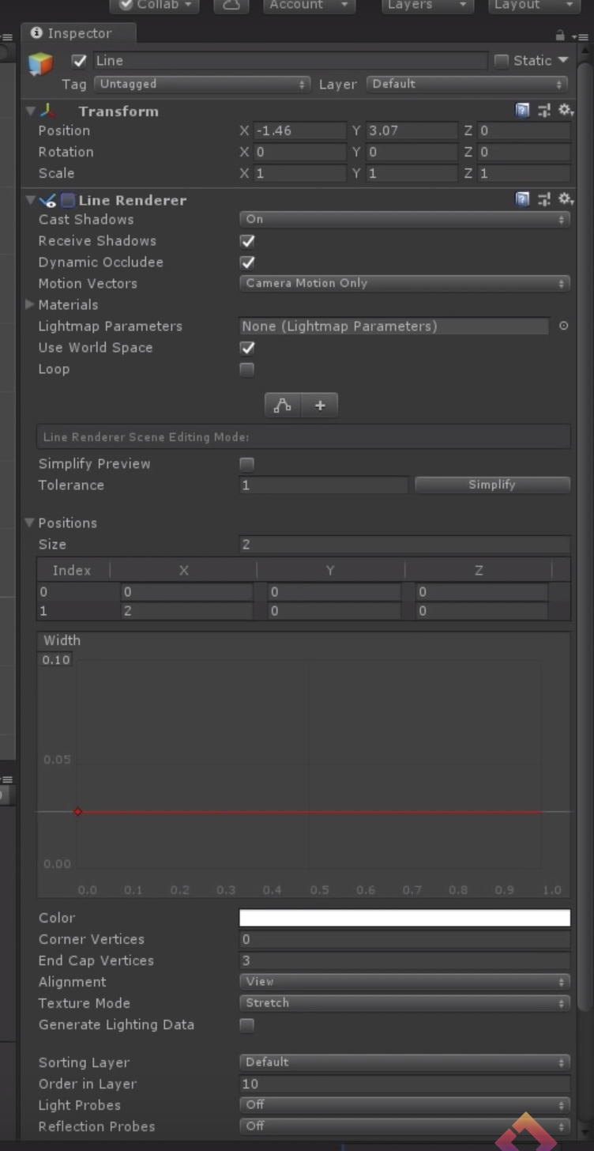

(Use world space - ?)

## Lec 39 – Create levels by making sprites follow path using Unity Sprite Shape

Watch the video: <https://www.youtube.com/watch?v=GSo_fU1JdfM&list=PLPV2KyIb3jR5QFsefuO2RlAgWEz6EvVi6&index=40&t=0s>

## Lec 40 – Animate 2D characters in Unity